**ReactCasparClient NRCS Manual**

Install nodejs from <https://nodejs.org/dist/v23.6.0/node-v23.6.0-x64.msi>

Use Casparcg server from here

<https://drive.google.com/file/d/1V1LZWQmss2O4gqG5wVSHLuW2J9Y8SDoj/view?usp=drive_link>

Unzip the software with 7z <https://7-zip.org/a/7z2409-x64.exe>

**Right click on Right_Click_Run_As_Administrator.bat from ReactCasparClient and run as administrator. A black window will open and close automatically.**

Double click start_both.bat file from unzipped ReactCasparClient folder. Open <https://localhost::10000/ReactCasparClient>

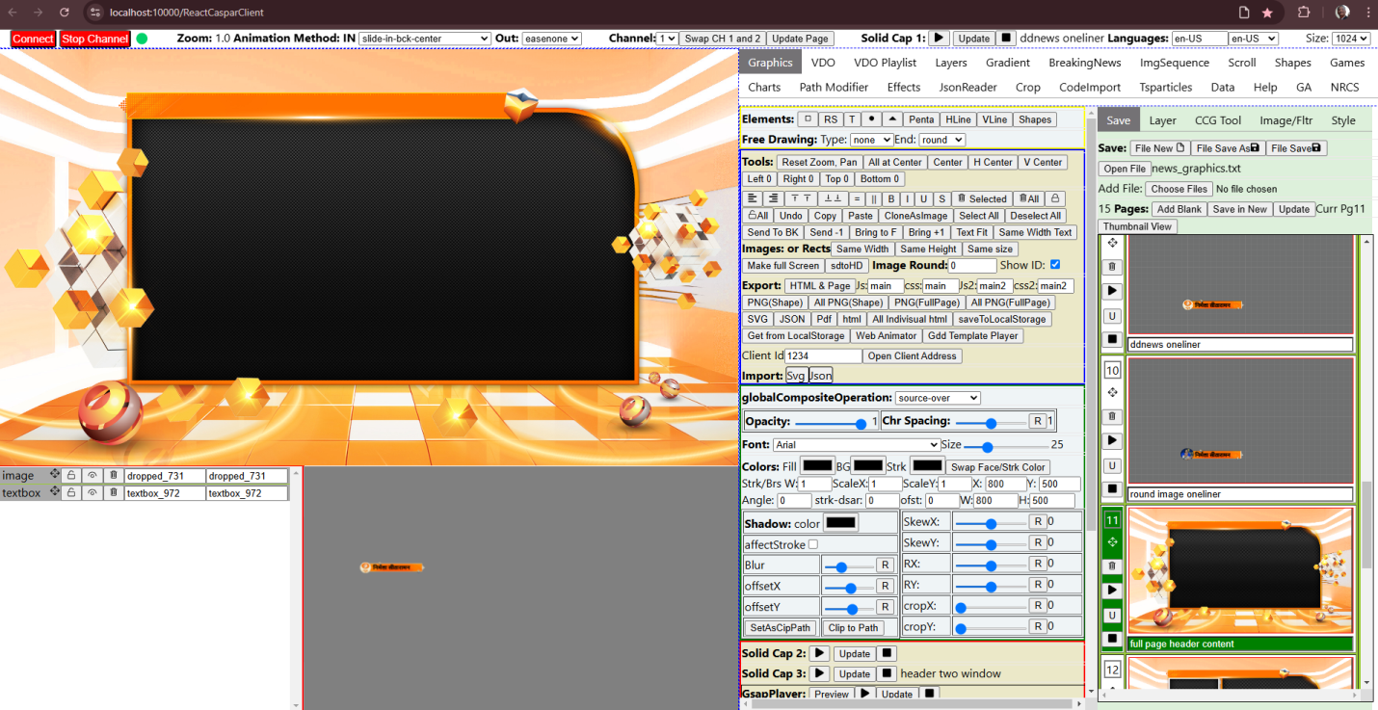

   We need to go to NRCS tab for NRCS operations. Select date and Run Order for NRCS. Select required slug for which graphics is to be made and attached. Select a template from template list and then add text or images on it by right clicking. Then click add new button.

If we need to modify any graphics select it and then modify then click Update graphics button.

We can play the graphics by clicking play button, Update button then stop by stop button in Thumbnail view Tab.

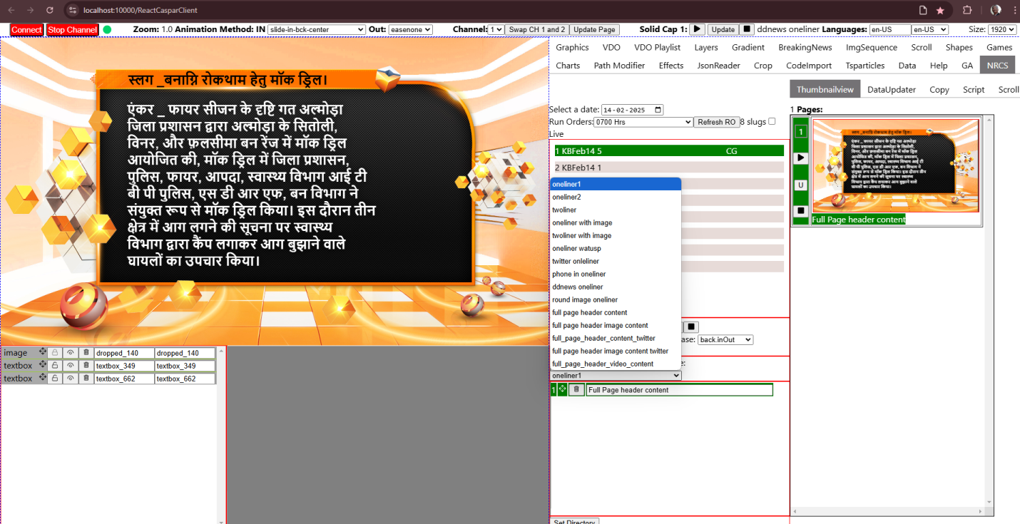

We can copy CG from other runorder from Copy Tab. Select required date and run order and then select slug name. GHraphics will be listed there. We can see what is there in graphics by clicking the name. Then we can drag from there and drop to left side run order selected slug.

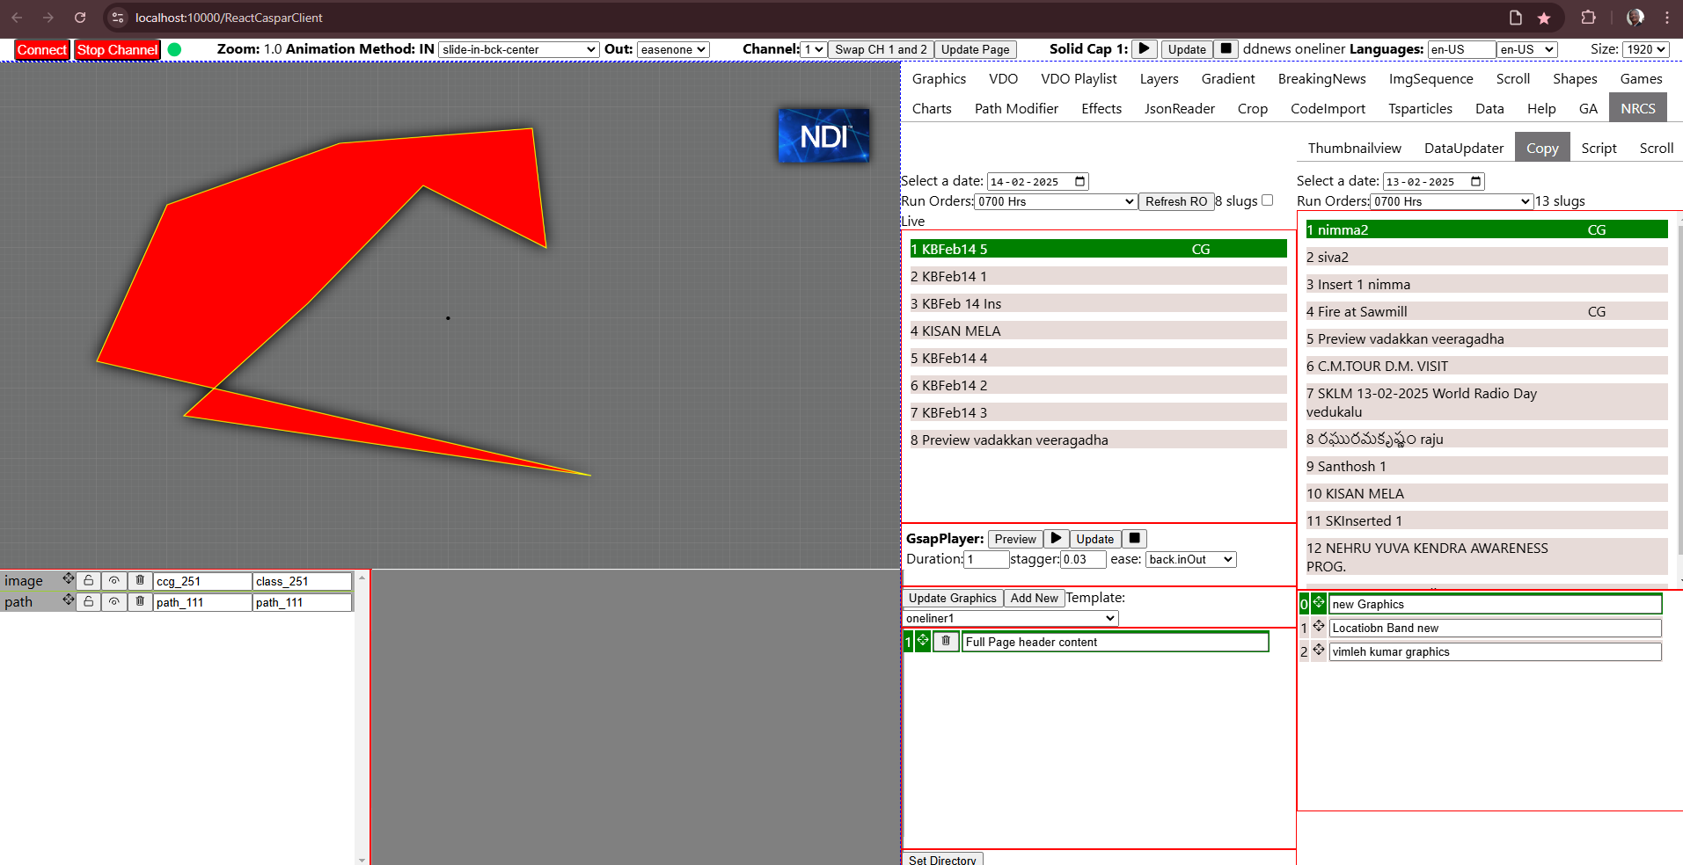

Script tab is for seeing One-liner and script of selected slug and we can use this to make graphics by copying from here and pasting to graphics designer. We can select text and drag also to Designer.

Scroll Tab will show various graphics for scroll, scroll from text file, Breaking news, News update, Two liner, Date and Time, and Full page Breaking News. We can play and stop with buttons. We can use Y location to shift the graphics vertically.

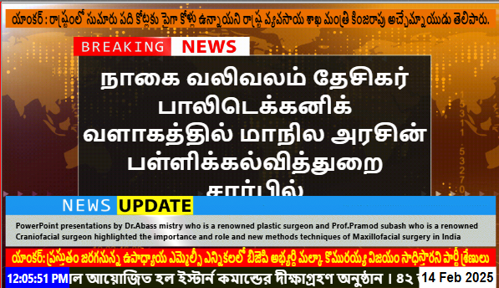

The data for these graphics comes from NRCS script type Special.

